**Student Questions**

Learn about the internals of a standard PC case by examining physical samples and selecting and labeling images found on-line. Gain deeper knowledge by researching and reporting on specific components.

PC Tower Case

1. Find one (or more) images that clearly show the internals of a PC Tower Case.   
   (i.e. Google images using keywords “PC Case Internals”)

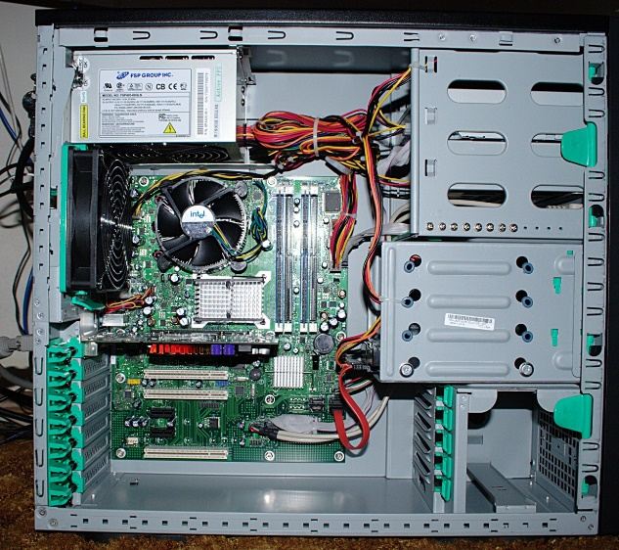

1. Clearly label the following components (using arrows) on your image of the PC case internals:
   1. Power Supply
   2. Hard Disk Drive
   3. Optical Disk Drive (e.g.DVD)
   4. USB Expansion Ports
   5. Monitor Port
   6. Audio Ports
   7. Ethernet Port
   8. Cooling Fan
   9. Motherboard

1. Research more in-depth about “Hard Disk Drives”. Make notes on the following:
   1. What different versions are currently available (speed and capacity)?

At this moment, there are four main groups of hard drives. The groups are Parallel Advanced Technology Attachment, Serial ATA, and Solid State Drives. A parallel Advanced Technology Attachment has a speeds between 16 MB/s to 66 MB/s with a maximum capacity of 1TB. A Serial ATA at the newest generation (SATA 3) has speeds of 6 Gb/s and maximum capacities of 2.5 to 3 TB. Solid State Drives have speeds of 550 MB/s and typically have capacities of 1Tb but can go up to 4 TB.

* 1. How the capacity of the component has changed since the 1980’s?

The capacity has changed a lot as now it is a lot more versatile. Most capacities of at least 1 TB whereas back in the 1980’s,that used to be the maximum capacity of the component.

PC Motherboard

1. Find one (or more) images that clearly show the layout of a PC Motherboard.   
   (i.e. Google images using keywords “PC Motherboard”)  
     
   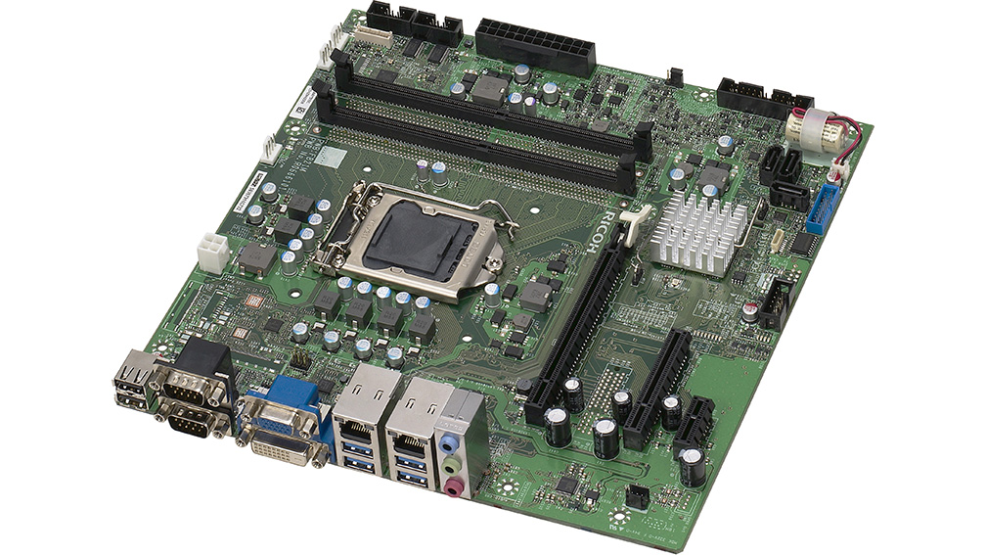
2. Clearly label the following components (using arrows) on your image of the PC motherboard:
   1. CPU (and fan)
   2. RAM Memory
   3. Disk Drive Interface (IDE or SATA)
   4. GPU Graphics Processor (either on-board or Graphics Card)
   5. Sound Processor (either on-board or Sound Card)
   6. Wi-Fi / Ethernet Network Interface (either on-board or Graphics Card)

1. Research more in-depth about “CPU Processor Chip”. Make notes on the following:
2. What different versions are currently available (speed and capacity)

Intel

i3- The speed is 2.4GHz

i5- The speed is 3.2 GHz

AMD- The speed is 3GHz

1. How the speed of the component has changed since the 1980’s

In the 1980’s, Processors were just the speed of MHz, this is a huge down grade as now we use computers with speeds of 2400 MHz instead of just 40!

Peripheral Devices

1. Find one (or more) images that clearly show the layout of the back of a typical PC tower case.   
   (i.e. Google images using keywords “Back Of PC Tower”)

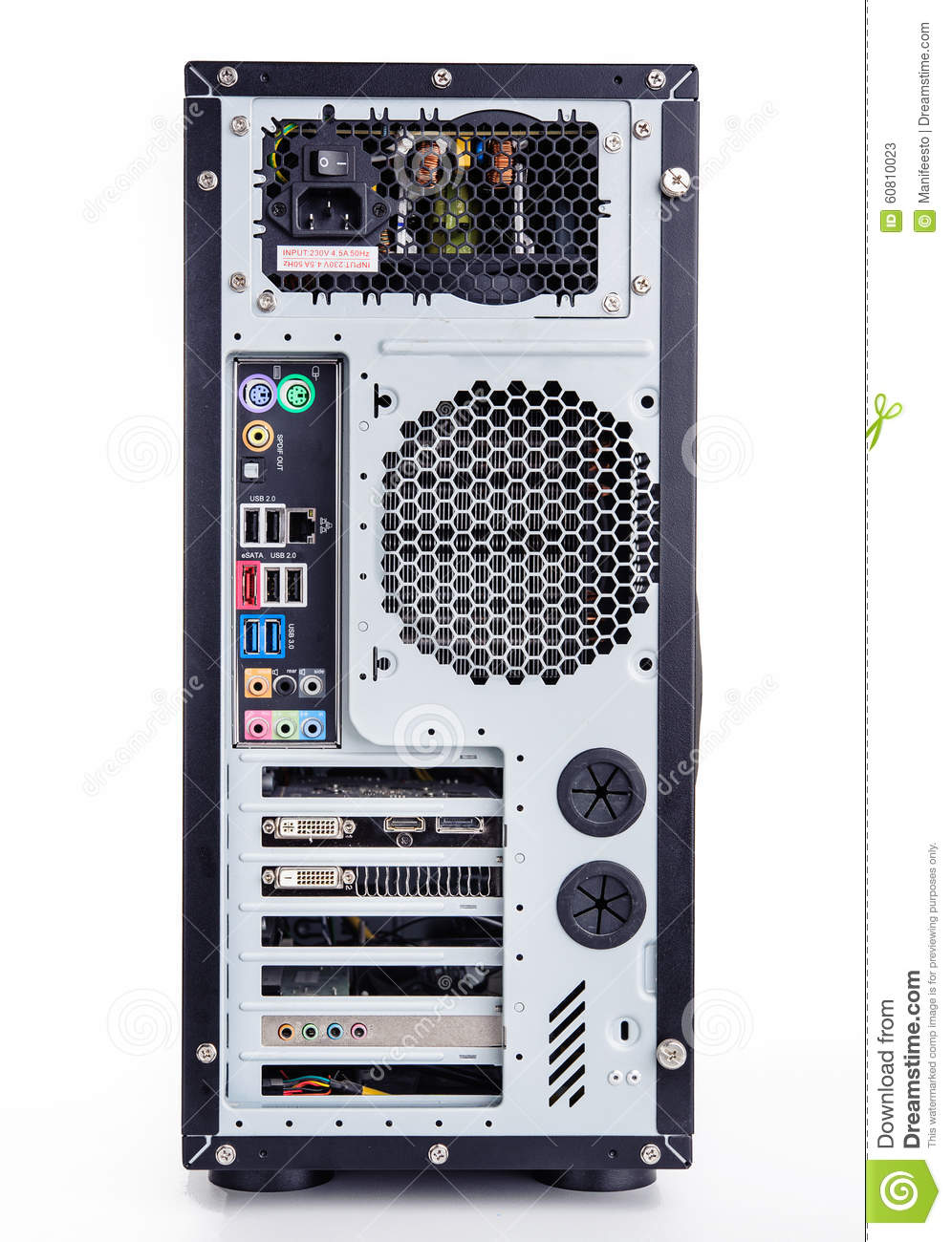

1. Clearly label the following components (using arrows) on your image of the back of a typical PC tower case:
   1. Power cord and power switch
   2. Monitor Interface (VGA or DVI or HDMI)
   3. Mouse Interface (USB or PS/2)
   4. Keyboard Interface (USB or PS/2)
   5. USB Ports
   6. Audio Inputs / Outputs
   7. Ethernet Interface

1. Research more in-depth about “External Portable Storage”. Make notes on the following:

.

a.   Floppy Disks

Type of disk storage which is a rectangular plastic enclosure. Still used by many manufacturers as save icons. It can only hold 1.44 MB.

b.   CD-ROM / DVD / Recordable CD/DVD

Digital optical disk which stores any kind of digital data. Used for software and other computer files as well as other media such as video. The maximum storage held on DVD’s are 9.4 GB.

c.        USB Memory Drives

Uses flash memory that is integrated into a USB interface. Much smaller and convenient than most other external portable storage which caused a huge rise in late 2000. It can hold up to 2 TB of storage.

d.   Compact Flash Memory

Mainly used in portable electronic devices such as phones because of the support with phones. Super small and just insert into the device causing no protrusion at all. Can hold up to 512 GB.

e.   Cloud-Based Storage

Works as a network of data servers in which drop and share as well as grant access to your files across many devices. Can go nearly infinitely but the cloud has to be made bigger causing a higher fee on the person who is purchasing.

**Presentation Outline**

Explore the development and features of a specific PC hardware component through deeper research and investigation. Work in partners to create a short presentation. Deliver the presentation to the class.

Each group will research a unique PC hardware component. Your specific topic will be assigned from the list provided below.

**Presentation Structure**

1. Explain what the PC component does and how it fits together with other components to make up a fully functioning PC.
2. Explain how the PC component works. Provide a diagram (image) showing the main parts of the component.
3. Research the current state of the art of the component in terms speed, capacity (size), and other related factors.
4. Research on-line suppliers that sell the PC Component. List the specifications for the available products and the cost (price).
5. Research how the PC component has changed and evolved since the early days of PCs in the 1980’s. Cover each of the following topics separately:
   1. Component Speed
   2. Component Size / Capacity
   3. Two other specifications specific to the PC component (ask Mr. Nestor)

**PC Component Topics**

|  |  |  |
| --- | --- | --- |
| **Topic** | **Partner 1** | **Partner 2** |
| CPU Microprocessor Chip |  |  |
| Motherboard Layout |  |  |
| Computer Graphics |  |  |
| Sound & Audio |  |  |
| Hard Disk Drives |  |  |
| Removable Disk Storage |  |  |
| Ethernet / Fiber Connectivity |  |  |
| Wifi / Bluetooth Connectivity |  |  |
| Mouse / Pointing Devices |  |  |
|  |  |  |
|  |  |  |
| Monitor & Display Technology |  |  |
| Printers & Output Technology |  |  |